**5th March 2019**

## Press Release

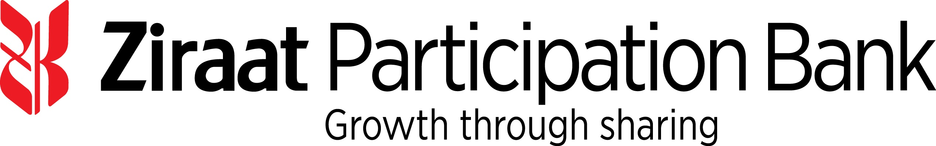

**Ziraat Katılım Bankası A.Ş.**

**US$ 150,000,000 Syndicated Murabaha Dual Currency Financing Facility**

Ziraat Katılım Bankası A.Ş. (“**Ziraat Participation**”, or the “**Bank**”), has mandated Bank ABC, Dubai Islamic Bank PJSC, Emirates NBD Capital Limited, Standard Chartered Bank and Warba Bank K.S.C.P (each an **"Initial Mandated Lead Arranger"** and **“Bookrunner”**)to arrange a US$ 150,000,000 Syndicated Dual Currency Murabaha Financing facility (the “**Facility**”).

Bank ABC is appointed as the Coordinator to the Facility.

The Facility has been structured as a Shari’a compliant Murabaha facility with a one-year and two- days tenor with a green-shoe option to increase the Facility size. The Facility will be denominated in US$ and EUR and the proceeds from the Facility will be used for general funding purposes.

Syndication was launched on 4th March 2019 and is expected to close in early April 2019.

## Bank Overview

Ziraat Katilim was founded by the decision of the Banking Regulation and Supervision Agency (“BRSA”) dated 10 October 2014 with an initial capital of TRY 675 million fully paid by the Turkish Treasury. The Bank commenced its operations by opening its first branch on 29 May 2015. Its head office is located in Istanbul. Following to its latest capital injection (on 23 October 2018), the paid up capital of Ziraat Katilim has reached TRY 1,750 million.

Ziraat Katilim is the first state owned participation bank in Turkey. As of the year end 2018, Ziraat Katilim has 80 branches across the country and it has 1,042 staff. In 2019 and 2020 the Bank plans to open 20 branches more in each year which will bring its number of branches to 120 by the end of 2020.

The vision of Ziraat Katilim is to become a leading participation bank in Turkey through expanding its branch network, using alternative distribution channels, diversifying its credit risk together with its funding base and enhanced service quality.

Ziraat Katilim managed increase its assets from TRY 14,350 million in 31 December 2017, to TRY 22,189 million as of 31 December 2018 which demonstrates significant growth.

Ziraat Katilim anticipates a rapid growth in assets reaching TRY 34 billion and TRY 47 billion by the end of 2019 and 2020 respectively.

Turkey is rated Ba3 by Moody’s, B+ by S&P and BB by Fitch.