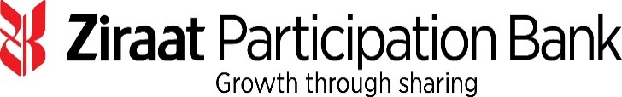

11 April 2019

**US$118 Million & EUR 121 Million Syndicated Dual Currency**

**Murabaha Financing facility**

Ziraat Participation Bank has successfully closed US$ 250 million equivalent Syndicated Dual Currency Murabaha Financing facility (the “Facility”). The Facility was signed on 10 April 2019.

Bank ABC, Dubai Islamic Bank PJSC, Emirates NBD Capital Limited, Standard Chartered Bank and Warba Bank K.S.C.P. (collectively the “Initial Mandated Lead Arrangers & Bookrunners”) were appointed to arrange a one year Syndicated Dual Currency Murabaha Financing Facility which was launched at US$ 150 million in the general syndication. Bank ABC acted as the Coordinator on the Facility and Warba Bank is the Investment Agent on the Facility.

Due to the significant oversubscription through 17regional and international participants, Ziraat Participation Bank increased the facility size to US$ 250 million (equivalent).

The Facility was structured as a Shari’a compliant commodity Murabaha facility and has given Ziraat Participation Bank the opportunity to broaden and diversify its funding base and develop new bank relationships. The proceeds will be used to expand its financing activities in Turkey.

**About Ziraat Katilim Bankasi A.Ş.**

Ziraat Katilim was founded by the decision of the Banking Regulation and Supervision Agency (“BRSA”) dated 10 October 2014 with an initial capital of TRY 675 million fully paid by the Turkish Treasury. The Bank commenced its operations by opening its first branch on 29 May 2015. Its head office is located in Istanbul. Following to its latest capital injection (on 23 October 2018), the paid up capital of Ziraat Katilim has reached TRY 1,750 million.

Ziraat Katilim is the first state owned participation bank in Turkey. As of the year end 2018, Ziraat Katilim has 80 branches across the country and it has 1,042 staff. In 2019 and 2020 the Bank plans to open 20 branches more in each year which will bring its number of branches to 120 by the end of 2020.

The vision of Ziraat Katilim is to become a leading participation bank in Turkey through expanding its branch network, using alternative distribution channels, diversifying its credit risk together with its funding base and enhanced service quality.

Ziraat Katilim managed increase its assets from TRY 14,350 million in 31 December 2017, to TRY 22,189 million as of 31 December 2018 which demonstrates significant growth.

Ziraat Katilim anticipates a rapid growth in assets reaching TRY 34 billion and TRY 47 billion by the end of 2019 and 2020 respectively.

Turkey is rated Ba3 by Moody’s, B+ by S&P and BB by Fitch.